**K. J. Somaiya College of Engineering, Mumbai-77**

Semester: ODD 22-23

**NAME**: Rahul Dandona

**ROLL NO.** : 16010421015

**BATCH**: IT - A1

Q1 Draw graph of the function and its fourier series (with n=50,n=10)

$f\left(x\right)={x.cos(x)}^{} , -π≤x≤π$

Code :

clc

L=%pi

x=-L:0.01:L;

f=x.*cos(x);

a0=(1/(2*L)*inttrap(x,f));

for n=1:50

f1=f.*cos(%pi*n*x*(1/L));

a(n)=(1/L)* inttrap(x,f1);

end;

for n=1:50

f2=f.*sin(%pi*n*x*(1/L));

b(n)=(1/L)* inttrap(x,f2);

end;

subplot(2,1,1), plot(x,f); *//* subplot(2,1,1)-in display 2 rows & 1column,’1’represnts first graph *of function;*

u=0; y=0;h=0;

for n=1:50

u= a(n)*cos(%pi*n*x*(1/L))+ b(n)* sin(%pi*n*x*(1/L))+y;

y=u;

end;

fs=y+ a0;

subplot(2,1,2), plot(x,fs); *//* subplot(2,1,2)-in display 2 rows & 1column,’2’represnts first graph of fourier series

title('ABC123456GRAPH1ifn=50','fontsize',5)

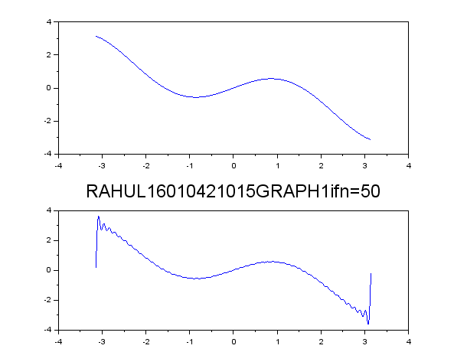

clc

L=%pi

x=-L:0.01:L;

f=x.*cos(x);

a0=(1/(2*L)*inttrap(x,f));

for n=1:10

f1=f.*cos(%pi*n*x*(1/L));

a(n)=(1/L)* inttrap(x,f1);

end;

for n=1:10

f2=f.*sin(%pi*n*x*(1/L));

b(n)=(1/L)* inttrap(x,f2);

end;

subplot(2,1,1), plot(x,f); *// subplot(2,1,1)-in display 2 rows & 1column,’1’represnts first graph of function;*

u=0; y=0;h=0;

for n=1:10

u= a(n)*cos(%pi*n*x*(1/L))+ b(n)* sin(%pi*n*x*(1/L))+y;

y=u;

end;

fs=y+ a0;

subplot(2,1,2), plot(x,fs); *// subplot(2,1,2)-in display 2 rows & 1column,’2’represnts first graph of fourier series*

title('RAHUL16010421015GRAPH1ifn=10','fontsize',5)

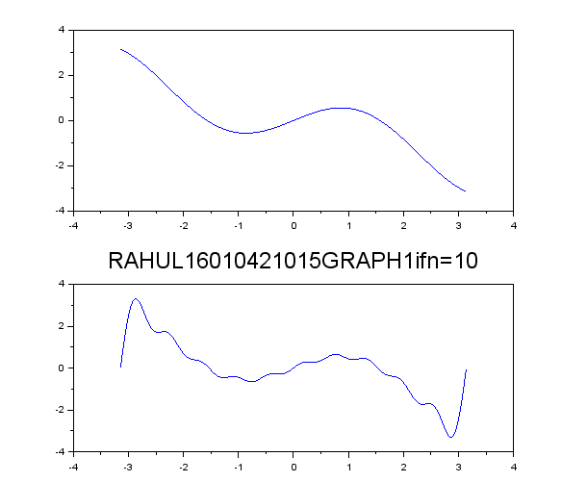

Q2 Draw graph of the function and its fourier series (with n=50,n=10)

$f\left(x\right)={x +x^{2}}^{} , 0≤x≤2π$

clc

L=%pi

x=0:0.01:2*L;

f=x+x^2;

a0=(1/(2*L)*inttrap(x,f));

for n=1:10

f1=f.*cos(%pi*n*x*(1/L));

a(n)=(1/L)* inttrap(x,f1);

end;

for n=1:10

f2=f.*sin(%pi*n*x*(1/L));

b(n)=(1/L)* inttrap(x,f2);

end;

subplot(2,1,1), plot(x,f); *//* subplot(2,1,1)-in display 2 rows & 1column,’1’represnts first graph *of function;*

u=0; y=0;h=0;

for n=1:10

u= a(n)*cos(%pi*n*x*(1/L))+ b(n)* sin(%pi*n*x*(1/L))+y;

y=u;

end;

fs=y+ a0;

subplot(2,1,2), plot(x,fs); *//* subplot(2,1,2)-in display 2 rows & 1column,’2’represnts first graph of fourier series

title('RAHUL16010421015GRAPH1ifn=10','fontsize',5)

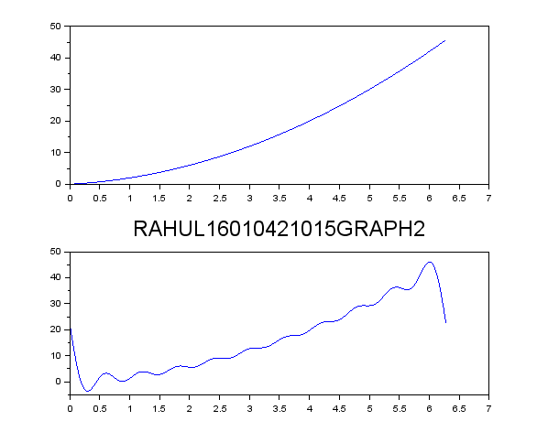

clc

L=%pi

x=0:0.01:2*L;

f=x+x^2;

a0=(1/(2*L)*inttrap(x,f));

for n=1:50

f1=f.*cos(%pi*n*x*(1/L));

a(n)=(1/L)* inttrap(x,f1);

end;

for n=1:50

f2=f.*sin(%pi*n*x*(1/L));

b(n)=(1/L)* inttrap(x,f2);

end;

subplot(2,1,1), plot(x,f); *// subplot(2,1,1)-in display 2 rows & 1column,’1’represnts first graph of function;*

u=0; y=0;h=0;

for n=1:50

u= a(n)*cos(%pi*n*x*(1/L))+ b(n)* sin(%pi*n*x*(1/L))+y;

y=u;

end;

fs=y+ a0;

subplot(2,1,2), plot(x,fs); *// subplot(2,1,2)-in display 2 rows & 1column,’2’represnts first graph of fourier series*

title('RAHUL16010421015GRAPH1ifn=50','fontsize',5)

